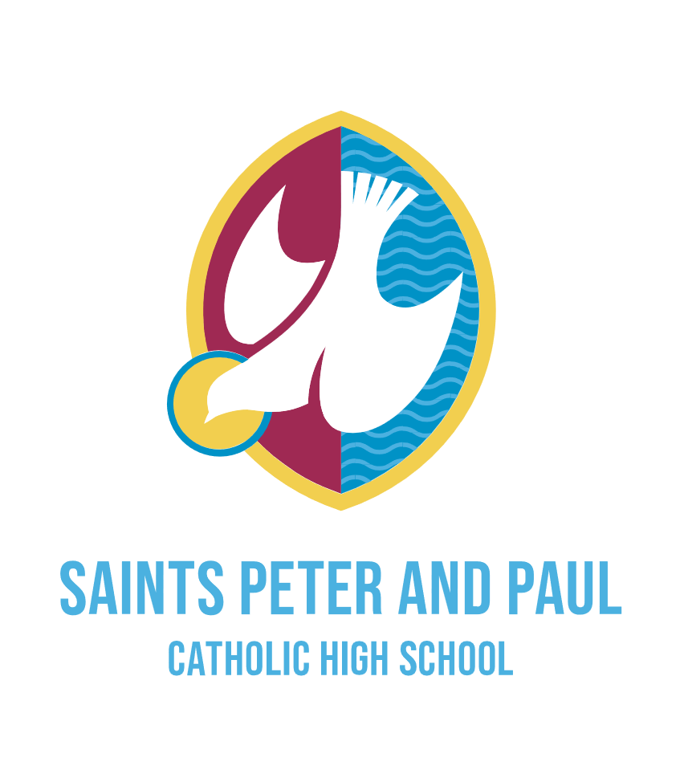

Associate Assistant Principal: SENDCO
(L9 – 13)
£57,480 - £63,430

An exciting opportunity has arisen for a dynamic and inspirational leader to join our school community to lead on the support of students with Special Education Needs and Disabilities. We are seeking to appoint a strategic thinker, an outstanding teacher and someone able to inspire, lead and motivate students and staff.

The Associate Assistant Principal SENDCO will work closely with the Governing body, Senior Leadership Team and SEND team to further enhance the curriculum, teaching, learning and assessment to secure the best possible outcomes. The SEND team is a strong group which consists of an Assistant SENDCO, an Inclusion Manger, two Lead Mentors and a team of TAs, some of which lead specialist provision.

This is an ideal opportunity for a current SENDCO from any setting, who is looking to take the next steps into senior leadership. The role also has the time attached to it that will allow for the individual to lead the SEND team strategically.

At our warm and welcoming school, we focus on our core values of respect, compassion and aspiration and every member of staff plays an important role in promoting these values every day.

In our most recent Ofsted inspection in July 2022, we were rated as ‘Good’ and we are currently preparing for our upcoming Section 48 Inspection

We will offer you the opportunity to;

- Be welcomed into our supportive staff team and experience our special sense of community
- Be supported in your continued professional development
- Become part of the extremely strong and supportive Archdiocese of Liverpool Secondary School Improvement Trust in which there are regular opportunities to collaborate and share practice

Prospective applicants are most welcome to discuss the position and arrange a visit by telephoning Mr Caine, Assistant Principal on the main school number, 0151 424 2139.

Further information and an application form can be found on the school website: www.saintspeterandpaul.halton.sch.uk.

Please send completed CES application forms to Mrs Marcela Cotes, Personnel Officer, at the below address. Alternatively, they can be e-mailed to: recruitment@saintspeterandpaul.halton.sch.uk

Strictly no CVs. CES Application forms only with supporting statement.

Closing date for applications is 9am Monday 6th May 2024
Interviews scheduled for later that same week.

Saints Peter and Paul Catholic High School is committed to safeguarding and promoting the welfare of students and the post is subject to an enhanced DBS check and references

